Worksheet
First Condition of Static Equilibrium

1. A tightrope walker, who has a mass of 60.0 kg moves to the center of the wire, which causes the wire to sag and make a 6.0 angle with the horizontal, Calculate the tension in the wire.
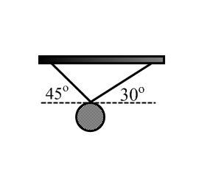
2. A mirrored sphere, weighing 200.0 N is suspended from the ceiling of a ballroom by two cables as shown in the diagram. What is the tension in each of these cables?

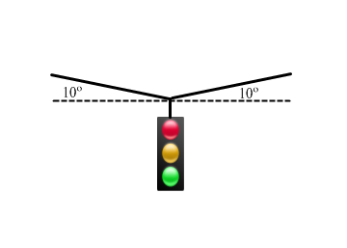
3. A traffic light is supported by a cable that makes an angle of 10 with the horizontal on each side of the light. The maximum safe tension in cable is 1.0 10³ N. What is the maximum safe mass for the light?

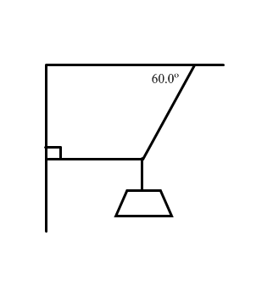
4. Calculate the tension in the two cords that support the 500.0 N weight as shown in the diagram.

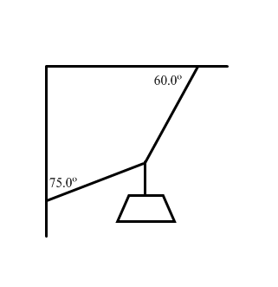
5. Calculate the tension in the two cords that support the 4.50 kg mass as shown in the diagram.

6. Calculate the mass of the suspended object, given the tension in the horizontal cord shown in the diagram is 400.0 N.
